# New Media Academy Life

## What is New Media Academy Life?

**# Source**: **Chatgpt (GPT-5-Standard) at [8/27/2025]**

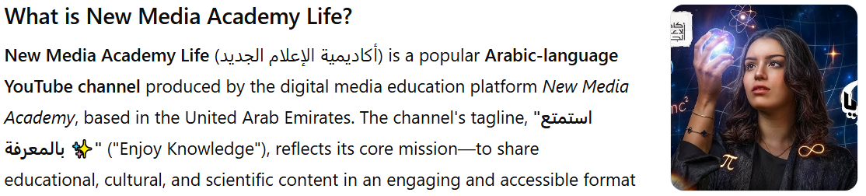

**New Media Academy Life** (أكاديمية الإعلام الجديد) is a popular **Arabic-language YouTube channel** produced by the digital media education platform *New Media Academy*, based in the United Arab Emirates. The channel's tagline, **"استمتع بالمعرفة ✨"** ("Enjoy Knowledge"), reflects its core mission—to share educational, cultural, and scientific content in an engaging and accessible format ([YouTube](https://www.youtube.com/c/NewMediaAcademy?utm_source=chatgpt.com), [analytics.wizdeo.com](https://analytics.wizdeo.com/en/channels/detail/2411427-New_Media_Academy_Life?utm_source=chatgpt.com), [stage.recode.net](https://stage.recode.net/courses/new-media-academy-life.html?utm_source=chatgpt.com)).

It features a wide variety of topics, including:

* History and historical narratives
* Scientific explorations
* Literature summaries
* Architectural analysis
* Psychological guidance
* Politics, economics, and ethics
* Linguistics, arts, artificial intelligence, and environmental conservation

The goal is to spark curiosity and inspire deeper reflection across diverse fields ([analytics.wizdeo.com](https://analytics.wizdeo.com/en/channels/detail/2411427-New_Media_Academy_Life?utm_source=chatgpt.com)).

## Key Highlights

**# Source**: **Chatgpt (GPT-5-Standard) at [8/27/2025]**

* **Platform:** YouTube
* **Language:** Arabic
* **Launch Date:** June 13, 2020 ([vidIQ](https://vidiq.com/youtube-stats/channel/UCtJmfVv0a52Bu7BnJJtZXKw/?utm_source=chatgpt.com" \o "New Media Academy Life 's Subscriber Count, Stats & Income - vidIQ YouTube Stats), [SPEAKRJ](https://www.speakrj.com/audit/report/UCtJmfVv0a52Bu7BnJJtZXKw/youtube?utm_source=chatgpt.com))
* **Focus Areas:** Multidisciplinary educational content—history, science, culture, architecture, psychology, and more
* **Motto:** “استمتع بالمعرفة” (“Enjoy Knowledge”) ([YouTube](https://www.youtube.com/c/NewMediaAcademy?utm_source=chatgpt.com))
* **Geographic Base:** United Arab Emirates ([analytics.wizdeo.com](https://analytics.wizdeo.com/en/channels/detail/2411427-New_Media_Academy_Life?utm_source=chatgpt.com), [vidIQ](https://vidiq.com/youtube-stats/channel/UCtJmfVv0a52Bu7BnJJtZXKw/?utm_source=chatgpt.com))

## Summary Table

**# Source**: **Chatgpt (GPT-5-Standard) at [8/27/2025]**

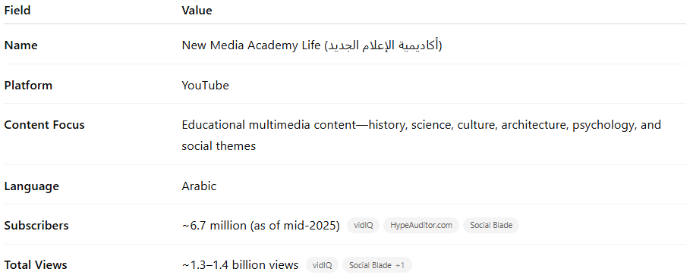

| **Field** | **Value** |
| --- | --- |
| **Name** | New Media Academy Life (أكاديمية الإعلام الجديد) |
| **Platform** | YouTube |
| **Content Focus** | Educational multimedia content—history, science, culture, architecture, psychology, and social themes |
| **Language** | Arabic |
| **Subscribers** | ~6.7 million (as of mid-2025) ([vidIQ](https://vidiq.com/youtube-stats/channel/UCtJmfVv0a52Bu7BnJJtZXKw/?utm_source=chatgpt.com" \o "New Media Academy Life 's Subscriber Count, Stats & Income - vidIQ YouTube Stats), [HypeAuditor.com](https://hypeauditor.com/youtube/UCtJmfVv0a52Bu7BnJJtZXKw/?utm_source=chatgpt.com), [Social Blade](https://socialblade.com/youtube/channel/UCtJmfVv0a52Bu7BnJJtZXKw?utm_source=chatgpt.com)) |
| **Total Views** | ~1.3–1.4 billion views ([vidIQ](https://vidiq.com/youtube-stats/channel/UCtJmfVv0a52Bu7BnJJtZXKw/?utm_source=chatgpt.com" \o "New Media Academy Life 's Subscriber Count, Stats & Income - vidIQ YouTube Stats), [Social Blade](https://socialblade.com/youtube/channel/UCtJmfVv0a52Bu7BnJJtZXKw?utm_source=chatgpt.com)) |